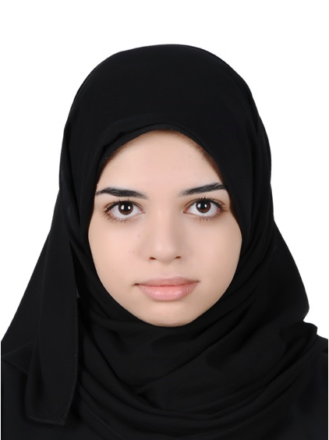

Ghadeer yousif marhoon alajami
Mobile: 66361729
E-mail: gadeer1993_5@hotmail.com

Personal Information | - Marital status: Single  - Nationality: Bahraini  - CPR. No: 930508700  - Place of Birth: Jidhafs Maternity Hospital– Bahrain  - Date of Birth: 16/5/1993  - Address: Villa # 1638 – Road #3845 – Block # 538 Al-Duraz – Kingdom of Bahrain
Education | University Of Bahrain  - L.L.B in law (Excellent)  - Associate Diploma in Instrumentation and Control at the college of Information Technology at the end of the semester Session 2013/2014
Key Skills | - The ability to understand and analyse laws and provisions  - Good Command of Arabic Language.  - Good computer literacy in some MS applications, Internet applications.  - Forms and retains excellent relationships with colleagues and clients.  - Ability to learn more and work
Working Experiences | - Ministry of works , municipalities affairs and Urban planning  - Isa town llibrary  - Ministry of Industry and Commerce
Languages | - English: good (reading, writing and speaking).  - Arabic: excellent (reading, writing and speaking).
Interests | Modern computing studies, internet, reading, traviling.

